MANAGEMENT INFORMATION SYSTEM

IN BARANGAY NEW PANDAN, PANABO CITY

A Capstone Project by

JEFFERN MALINAO

CHRISTOPHER A. ESTRERA

KATRINA DE RAMOS

Submitted to the College Department

Northlink Technological College – Panabo City

In Partial Fulfillment

of the Requirements for the Degree

Bachelor of Science in Information Systems

January 2023

APPROVAL SHEET

This capstone project entitled **Management Information System in Barangay New Pandan, Panabo City**, prepared and submitted by **Jeffern Malinao, Christopher A. Estrera, Katrina De Ramos** in partial fulfillment of the requirements for the degree **Bachelor of Science in Information System** is hereby accepted.

|  |  |
| --- | --- |
| **<Adviser>** | |
| Research Paper Adviser | |
| **Aiza M. Romano** | |
| Chair, Defense Panel | |
| **<Panelist 1>** | **<Panelist 2>** |
| Panel Member | Panel Member |

Accepted and approved for the conferral of the degree **Bachelor of Science in Information System**

**Aiza M. Romano, DIT**

Dean, College Department

DEDICATION

This capstone is dedicated to the resilient residents of Barangay New Pandan, Panabo City, led by Brgy Captain Michael John Badal and SK Chairman Victor Anthony Badilla Padios. Your support, generosity, and willingness to share your experiences have been invaluable to this project. We dedicate this work to you, hoping it contributes to the continued development of your community.

We also dedicate this capstone to ourselves, Jeffern Malinao, Christopher Estrera, and Katrina de Ramos, for our dedication, perseverance, and passion in making this project possible. Our teamwork and belief in each other have been the driving force behind our success.

We extend our heartfelt dedication to our teachers, whose guidance and support have inspired us throughout our academic journey. Your contributions to our education and personal growth are deeply appreciated.

Lastly, we dedicate this capstone to our families, whose unwavering support and sacrifices have been the foundation of our achievements. Your love and encouragement have given us the strength to pursue our dreams with determination. We are forever grateful for everything you have done for us.

ACKNOWLEDGMENTS

We would like to express our heartfelt gratitude to everyone who has contributed to the success of our capstone project.

To the residents of Barangay New Pandan, Panabo City, thank you for inspiring us and being the driving force behind this project. Your unwavering support, generosity, and willingness to share your experiences have been the foundation of our work. We hope our project contributes to the development and prosperity of your community.

To our advisors and teachers, thank you for your guidance, feedback, and support throughout the project. Your expertise and advice have been invaluable, and we will carry the knowledge and skills you've imparted throughout our careers.

To our friends and colleagues, thank you for your encouragement and unwavering support. Your belief in us has meant the world, and we are grateful to have you by our side.

As we conclude our capstone project, we reflect on the challenges, lessons, and memories we've gained. We are proud of our accomplishments and excited for what lies ahead.

We are grateful for the opportunity to work on this project and the experiences that came with it. We hope our work contributes to a better society and inspires others to pursue their dreams with passion and determination.

Once again, we extend our deepest appreciation to everyone who contributed to the success of our capstone project. Thank you for being a part of our journey, and we eagerly anticipate what the future holds.

TABLE OF CONTENTS

APPROVAL SHEET ii

DEDICATION iii

ACKNOWLEDGMENTS iv

TABLE OF CONTENTS vi

LIST OF TABLES viii

LIST OF FIGURES ix

ABSTRACT xi

1 INTRODUCTION 13

1.1 Background of the Study 13

1.2 Objectives of the Study 14

1.3 Significance of the Study 15

1.4 Scope and Delimitations 17

2 THEORETICAL FRAMEWORK 20

2.1 Review of Related Literature 20

2.2 Concept of the Study 25

2.3 Definition of Terms 26

3 OPERATIONAL FRAMEWORK 31

3.1 Materials 31

3.1.1 Software 31

3.1.2 Hardware 32

3.1.3 Data 33

3.2 Methods 34

3.2.1 Experimental design 35

3.2.2 Procedures for the different phases 36

3.2.3 Evaluation 38

3.3 Amenities Images 40

LIST OF TABLES

Table 3-1. List of Software Requirements ...………………………………………………………..….. 30

Table 3-2. List of Hardware Requirements ...………………………………………………..……….… 31

Table 3-3. Amenities Image ….……………………………………………………………….…………. 35

LIST OF FIGURES

Figure 3.0. DFD Level 0 ……..………………...……..………………………………………… 24

Figure 3.1. Agile Model ……………………………….………………………………………… 34

Figure 3.2. Home Page ………………………………………………..…….………………..… 40

Figure 3.3. Secretary Login …………………………………………………………………….. 41

Figure 3.4. Dashboard ……………………………………………………………………………41

Figure 3.5. Barangay Officials …………………………………………………………………...42

Figure 3.6. Barangay Officials (Add Official) …………………………………………………. 42

Figure 3.7. Purok Leader ……………………………………………………………………….. 43

Figure 3.8. Purok Leader (Add Purok Leader) ………………………………………………...43

Figure 3.9. Resident Profiling …………………………………………………………………... 44

Figure 4.0. Resident Profiling (Add Resident) ………………………………………………... 45

Figure 4.1. Household …………………………………………………………………………... 46

Figure 4.2. Household (Add Household) ……………………………………………………… 46

Figure 4.3. Blotter ………………………………………………………………………………... 47

Figure 4.4. Blotter (Add Blotter) ………………………………………………………………... 47

Figure 4.5. Clearance …………………………………………………………………………… 48

Figure 4.6. Clearance (Add Clearance) ………………………………………………………. 48

Figure 4.7. Announcement …………………………………………………………………….. 49

Figure 4.8. Announcement (Add Announcement) …………………………………………… 49

Figure 4.9. Reports ……………………………………………………………………………… 50

Figure 5.0 Logs ………………………………………………………………………………….. 50

Figure 5.1. System Settings (Light Theme) ..…………………………………………………. 51

Figure 5.2. System Settings (Dark Theme) ..…………………………………………………. 51

Figure 5.2. Logout ……………………………………………………………………………….. 52

Figure 5.3. Resident Account (New Clearance Request) …………………………………… 52

Figure 5.4. Resident Account (Approval Clearance Request) ……………………………… 53

Figure 5.5. Resident Account (Request Clearance) …………………………………………. 53

Figure 5.6. Resident Account (Announcement) ……………………………………………… 54

Figure 5.7. Purok Leader (Clearance Request List) ……………………..………………….. 54

Figure 5.8. Purok Leader (Clearance Request Approval) …………….…………………….. 55

ABSTRACT

The capstone project titled "Barangay Management Information Systems for Barangay New Pandan, Panabo City" aims to develop a comprehensive web-based information system to enhance the management and operations of the barangay. This system will enable streamlined administrative processes, accurate record-keeping, and efficient communication within the community. The project's primary objective is to achieve an effective and modernized barangay management system, empowering Barangay New Pandan with transparent governance, improved efficiency, and enhanced services for its residents.

This project involves the design and implementation of a user-friendly website that integrates various modules to address the specific needs of Barangay New Pandan. These modules include but are not limited to resident profiling, barangay officials' management, document management, and reporting functionalities.

The website will serve as a centralized platform for data collection, storage, and retrieval, ensuring the availability of up-to-date and accurate information. Residents will be able to access services, submit requests, and stay informed about barangay announcements through the website.

The system will enable efficient management of barangay operations, such as the issuance of certificates and monitoring of community households. It will facilitate faster response times, improve decision-making processes, and foster transparency and accountability in the barangay administration.

Through this project, Barangay New Pandan will experience a significant transformation in its information management practices, leading to enhanced service delivery and better governance. The website-based Barangay Management Information System will empower barangay officials and residents alike, promoting a more efficient, accessible, and responsive local government.

# INTRODUCTION

## Background of the Study

Barangay New Pandan, located in Panabo City, Davao del Norte, is a vibrant community comprising a diverse population. As with many barangays in the Philippines, New Pandan faces the challenge of managing various administrative tasks, maintaining accurate records, and providing efficient services to its residents. The current manual system of managing barangay operations, relying heavily on paper-based documentation and traditional communication methods, has proven to be time-consuming, prone to errors, and inefficient in meeting the growing demands of the community.

With the rapid advancements in technology and the increasing availability of digital solutions, there is a pressing need to modernize the management information system of Barangay New Pandan. A comprehensive and user-friendly Management Information System (MIS) tailored to the specific requirements of the barangay can revolutionize the way administrative tasks are handled, data is collected and analyzed, and services are delivered to the residents.

A critical aspect of improving barangay governance is the ability to collect, store, retrieve, and analyze data efficiently. The existing manual system makes it challenging to maintain accurate resident profiles, issue certificates, and generate reports. Furthermore, communication within the barangay and between residents and barangay officials is often hindered by the lack of a centralized platform.

Studies have shown that the implementation of an effective MIS in barangays leads to improved transparency, streamlined operations, and enhanced service delivery. For instance, the use of digital platforms enables faster response times to resident inquiries and requests, enhances decision-making processes, and provides a more efficient means of communication. The implementation of a web-based MIS can significantly transform the way Barangay New Pandan manages its operations, fosters community engagement, and ultimately strengthens governance.

Statement of the Problem:

Despite the evident benefits of a modernized Management Information System, Barangay New Pandan continues to rely on manual and outdated methods of data management, communication, and service delivery. This outdated system hampers the barangay officials' ability to efficiently handle administrative tasks, provide timely services to residents, and ensure accurate record-keeping. Therefore, the problem this research aims to address is the lack of an efficient and comprehensive Management Information System in Barangay New Pandan, Panabo City.

## Objectives of the Study

General Objective:

The general objective of this study is to develop and implement a Management Information System (MIS) in Barangay New Pandan, Panabo City, to improve administrative processes, enhance service delivery, and promote efficient governance.

Specific Objectives:

1. To design and develop a web-based MIS that encompasses essential modules for resident profiling, purok leader, barangay officials' management, document management, announcement feature, logs and reporting functionalities:
2. To establish a centralized database for efficient data collection, storage, retrieval, and analysis within the MIS:
3. To evaluate the usability, functionality, and performance of the developed MIS through user testing and feedback:
4. To ensure data security and privacy within the MIS by implementing appropriate access controls and encryption measures:
5. To empower residents with up-to-date information on barangay announcements, events, and activities through the MIS.

## Significance of the Study

The implementation of a Management Information System (MIS) in Barangay New Pandan, Panabo City, holds significant importance and benefits for various stakeholders. The following are the key significance of this study:

1. Improvement in Administrative Efficiency: The developed MIS will streamline administrative processes, reducing paperwork, manual data entry, and repetitive tasks. This efficiency improvement will save time and resources for barangay officials, enabling them to focus on more critical decision-making and strategic planning.
2. Enhanced Service Delivery: The MIS will enable quicker response times to resident inquiries, requests, and complaints. Residents will experience improved access to barangay services, such as certificate issuance and information dissemination, leading to enhanced customer satisfaction and overall service quality.
3. Transparency and Accountability: The implementation of an MIS promotes transparency in the barangay's operations. Accurate and up-to-date data, coupled with standardized reporting features, will facilitate the monitoring of barangay projects, financial transactions, and service delivery, promoting accountability among barangay officials.
4. Improved Communication and Engagement: The web-based platform of the MIS will facilitate communication between barangay officials and residents. It will serve as a central hub for announcements, events, and activities, fostering community engagement, participation, and inclusivity.
5. Efficient Record-Keeping and Information Management: The MIS will provide a centralized database for accurate and secure storage of resident profiles, documents, and other relevant information. This centralized repository will minimize the risk of data loss, enhance data integrity, and facilitate easy retrieval of information when needed.
6. Long-Term Sustainability and Scalability: This study will provide insights into the implementation and maintenance of an MIS, ensuring its long-term sustainability and adaptability to future technological advancements. It will serve as a reference for other barangays or local government units seeking to implement similar systems.
7. Contribution to Knowledge and Research: This study will contribute to the existing body of knowledge in the field of information systems, particularly in the context of barangay management. It may serve as a reference for future researchers and students interested in studying and improving local governance through technology.

## Scope and Delimitations

Scope:

The scope of this capstone project, "Management Information System in Barangay New Pandan, Panabo City," includes the development and implementation of a web-based MIS specifically tailored for the needs of Barangay New Pandan. The project will cover the following key areas:

1. Resident Profiling: Designing a module to gather and maintain accurate resident information, including personal details, contact information, and household data.
2. Document Management: Creating a module to manage and track, barangay officials and barangay documents, including certificates to ensure proper documentation and retrieval.
3. Purok Leader: Can approve or disapprove purok clearance if the residents is cleared and that is required for requesting barangay certificates.
4. Announcement Feature: Implementing an announcement feature within the MIS to facilitate effective communication between barangay officials and residents.
5. Household: To define household number, purok, and how many people live in each household, and the head of the family.
6. Blotter Report: Includes essential information such as the date and location of the incident, as well as a detailed description of what transpired. It may also include the names, contact details, action taken and status.
7. Report: It allows secretary to generate and access important information in a simplified and organized manner. It provides a way to gather and present data in a structured format, enabling secretary to gain insights and make informed decisions about the barangay.
8. Logs: It allows the recording and tracking of important activities and events within a barangay. It functions as a digital logbook where relevant information is logged and stored for future reference and analysis.
9. System Settings: Added feature by reducing the amount of bright light emitted from screens, it can help reduce eye strain, eye fatigue, and sensitivity to bright lights.
10. Logout: Feature in a system refers to a functionality that allows users to securely end their session and disconnect from the system they are currently using.

Delimitations:

While this capstone project aims to address key challenges in barangay management, it is important to recognize its limitations and delimitations, which include:

1. Residents who are not duly registered in the system database can neither file complaints nor request documents;
2. Residents with no available internet connection cannot access the online barangay services, hence all requests and complaints in that case must be filed personally at the barangay office;
3. The system can only be accessed by system users as authorized by the system administrator.
4. The project assumes the availability of basic hardware (computers, servers) and a stable network infrastructure to support the implementation of the web-based MIS. However, detailed infrastructure setup is beyond the scope of this project.
5. While the project acknowledges the importance of data security, it focuses primarily on implementing basic access controls and encryption measures within the MIS. Advanced security measures, such as penetration testing or advanced encryption algorithms, may not be included.

# THEORETICAL FRAMEWORK

## Review of Related Literature

Effective management and governance at the barangay level necessitate efficient information management systems. The implementation of a Management Information System (MIS) is crucial in enhancing decision-making processes within barangays. An MIS provides a structured approach to collect, process, store, and disseminate information, enabling decision-makers to make informed choices (Deshmukh et al., 2019). It streamlines administrative processes, improves data accuracy, and facilitates communication among stakeholders, ultimately enhancing overall efficiency in barangay management.

Resident profiling is a key aspect of MIS implementation in barangays. Capturing and organizing resident data enables resource allocation, planning social services, and disaster response (Cruz, 2017). By maintaining accurate and up-to-date resident records, an MIS enables barangay officials to effectively manage community development initiatives and address the specific needs of residents.

Efficient document management is another critical area where an MIS proves beneficial. Hernandez et al. (2018) highlight the importance of document management systems in local government units, emphasizing how an MIS can streamline document storage, retrieval, and tracking processes. By providing a centralized platform for document management, an MIS reduces paperwork, minimizes the risk of document loss, and enables quick access to important records.

Transparency and accountability are fundamental principles of good governance, and an MIS can contribute significantly in this regard. Cabidog (2016) emphasizes that digitizing processes and data through an MIS enhances transparency by reducing the chances of manipulation, fraud, and unauthorized access. The system allows for improved monitoring of activities, financial transactions, and service delivery, empowering barangay officials to make evidence-based decisions.

Communication and engagement between barangay officials and residents are crucial for effective governance and community participation. An MIS serves as a platform to facilitate communication channels and engage residents in barangay affairs. Villanueva et al. (2020) discuss the role of ICT tools, including MIS, in enhancing citizen engagement and promoting a sense of ownership among residents. By providing residents with access to information, updates, and avenues for participation, an MIS fosters community engagement and empowers residents in decision-making processes.

Data security and privacy are paramount concerns in implementing an MIS. Flores (2018) highlights the importance of data privacy and security in information systems, particularly in handling sensitive resident information. Implementing appropriate data security measures, such as access controls, encryption, and backup systems, ensures the confidentiality and integrity of resident data within the MIS.

Usability and user acceptance are crucial factors in the successful implementation of an MIS. Involving users throughout the development process and providing adequate training and support are vital for effective utilization of the system (Cruz, 2020). User acceptance studies can provide valuable insights into factors influencing user satisfaction and adoption of the MIS, contributing to its overall success.

Data management and analysis are essential components of an effective MIS. Utilizing data analytics techniques can provide valuable insights for decision-making and resource allocation within barangays. Dela Cruz et al. (2019) emphasize the importance of data-driven decision-making and highlight how an MIS can enable the collection, analysis, and visualization of data to support evidence-based policies and programs.

The integration of Geographic Information System (GIS) technology with an MIS offers additional advantages for barangay management. GIS allows for spatial data analysis, mapping, and visualization, which can assist in identifying geographic patterns, planning infrastructure projects, and improving emergency response (Saripada et al., 2018). By incorporating GIS capabilities within the MIS, barangay officials can have a comprehensive view of their jurisdiction, leading to more informed decision-making processes.

Community engagement and participation are essential for fostering a sense of ownership and empowerment among residents. An MIS can facilitate citizen participation through online platforms, enabling residents to voice their concerns, provide feedback, and participate in surveys or polls (Pranowo et al., 2020). The inclusion of such features in the MIS can enhance the democratic processes within the barangay and create avenues for residents to actively contribute to community development.

The use of mobile technologies and applications can further enhance the accessibility and usability of the MIS. Mobile-based MIS applications provide convenience and flexibility, allowing barangay officials to access information and perform tasks on-the-go (Magallanes et al., 2019). With the increasing penetration of smartphones, the integration of mobile technologies in the MIS can improve data collection, communication, and service delivery within the barangay.

Continuous improvement and adaptation are crucial in maintaining the relevance and effectiveness of the MIS over time. Aguirre et al. (2019) highlight the importance of an iterative approach in MIS development, where feedback from users and stakeholders is actively sought and incorporated into system enhancements. By embracing an iterative and adaptive approach, the MIS can evolve to meet the changing needs and requirements of the barangay.

In addition to the aforementioned aspects, the literature also highlights the significance of transparency and accountability in barangay governance through the implementation of an MIS. Pardo and Aga (2017) emphasize that an MIS can enhance transparency by providing access to information and documents, allowing residents to monitor and evaluate the performance of barangay officials. This transparency can contribute to increased trust and public satisfaction in the governance processes.

Furthermore, studies have shown the positive impact of an MIS on the efficiency and effectiveness of service delivery in barangays. Das and Nandi (2016) conducted a study on the implementation of an MIS in a rural Indian village and found that it improved the speed and accuracy of service delivery, such as issuing certificates and permits. The MIS streamlined processes, reduced paperwork, and eliminated manual errors, leading to faster and more reliable services for the residents.

Collaboration and coordination among barangay officials and stakeholders are essential for effective governance. Chatterjee et al. (2018) emphasize the role of an MIS in facilitating communication and collaboration among various departments and agencies involved in barangay management. The MIS can serve as a centralized platform for sharing information, coordinating activities, and promoting synergy among stakeholders, ultimately leading to improved coordination and collaboration.

The adoption of an agile approach in MIS development has gained attention in recent years. Agile methodologies, such as Scrum, allow for iterative and incremental development, emphasizing collaboration, flexibility, and customer satisfaction. The Agile methodology enables close interaction between developers and end-users, ensuring that the developed MIS aligns with the actual needs and requirements of the barangay (Schwaber, 2004). This iterative approach allows for continuous feedback and adaptation, leading to a more user-centric and effective MIS.

Overall, the review of related literature underscores the importance of an MIS in barangay management, encompassing various aspects such as transparency, service delivery, collaboration, and the adoption of agile methodologies. The studies and findings from the literature provide valuable insights and guidance for the development and implementation of the "Management Information System in Barangay New Pandan, Panabo City" capstone project.

In summary, the review of related literature underscores the importance of an MIS in barangay management, encompassing various aspects such as data management and analysis, GIS integration, community engagement, mobile technologies, and continuous improvement. The findings from existing studies provide valuable insights and best practices that can inform the design, development, and implementation of the "Management Information System in Barangay New Pandan, Panabo City" capstone project.

## Concept of the Study

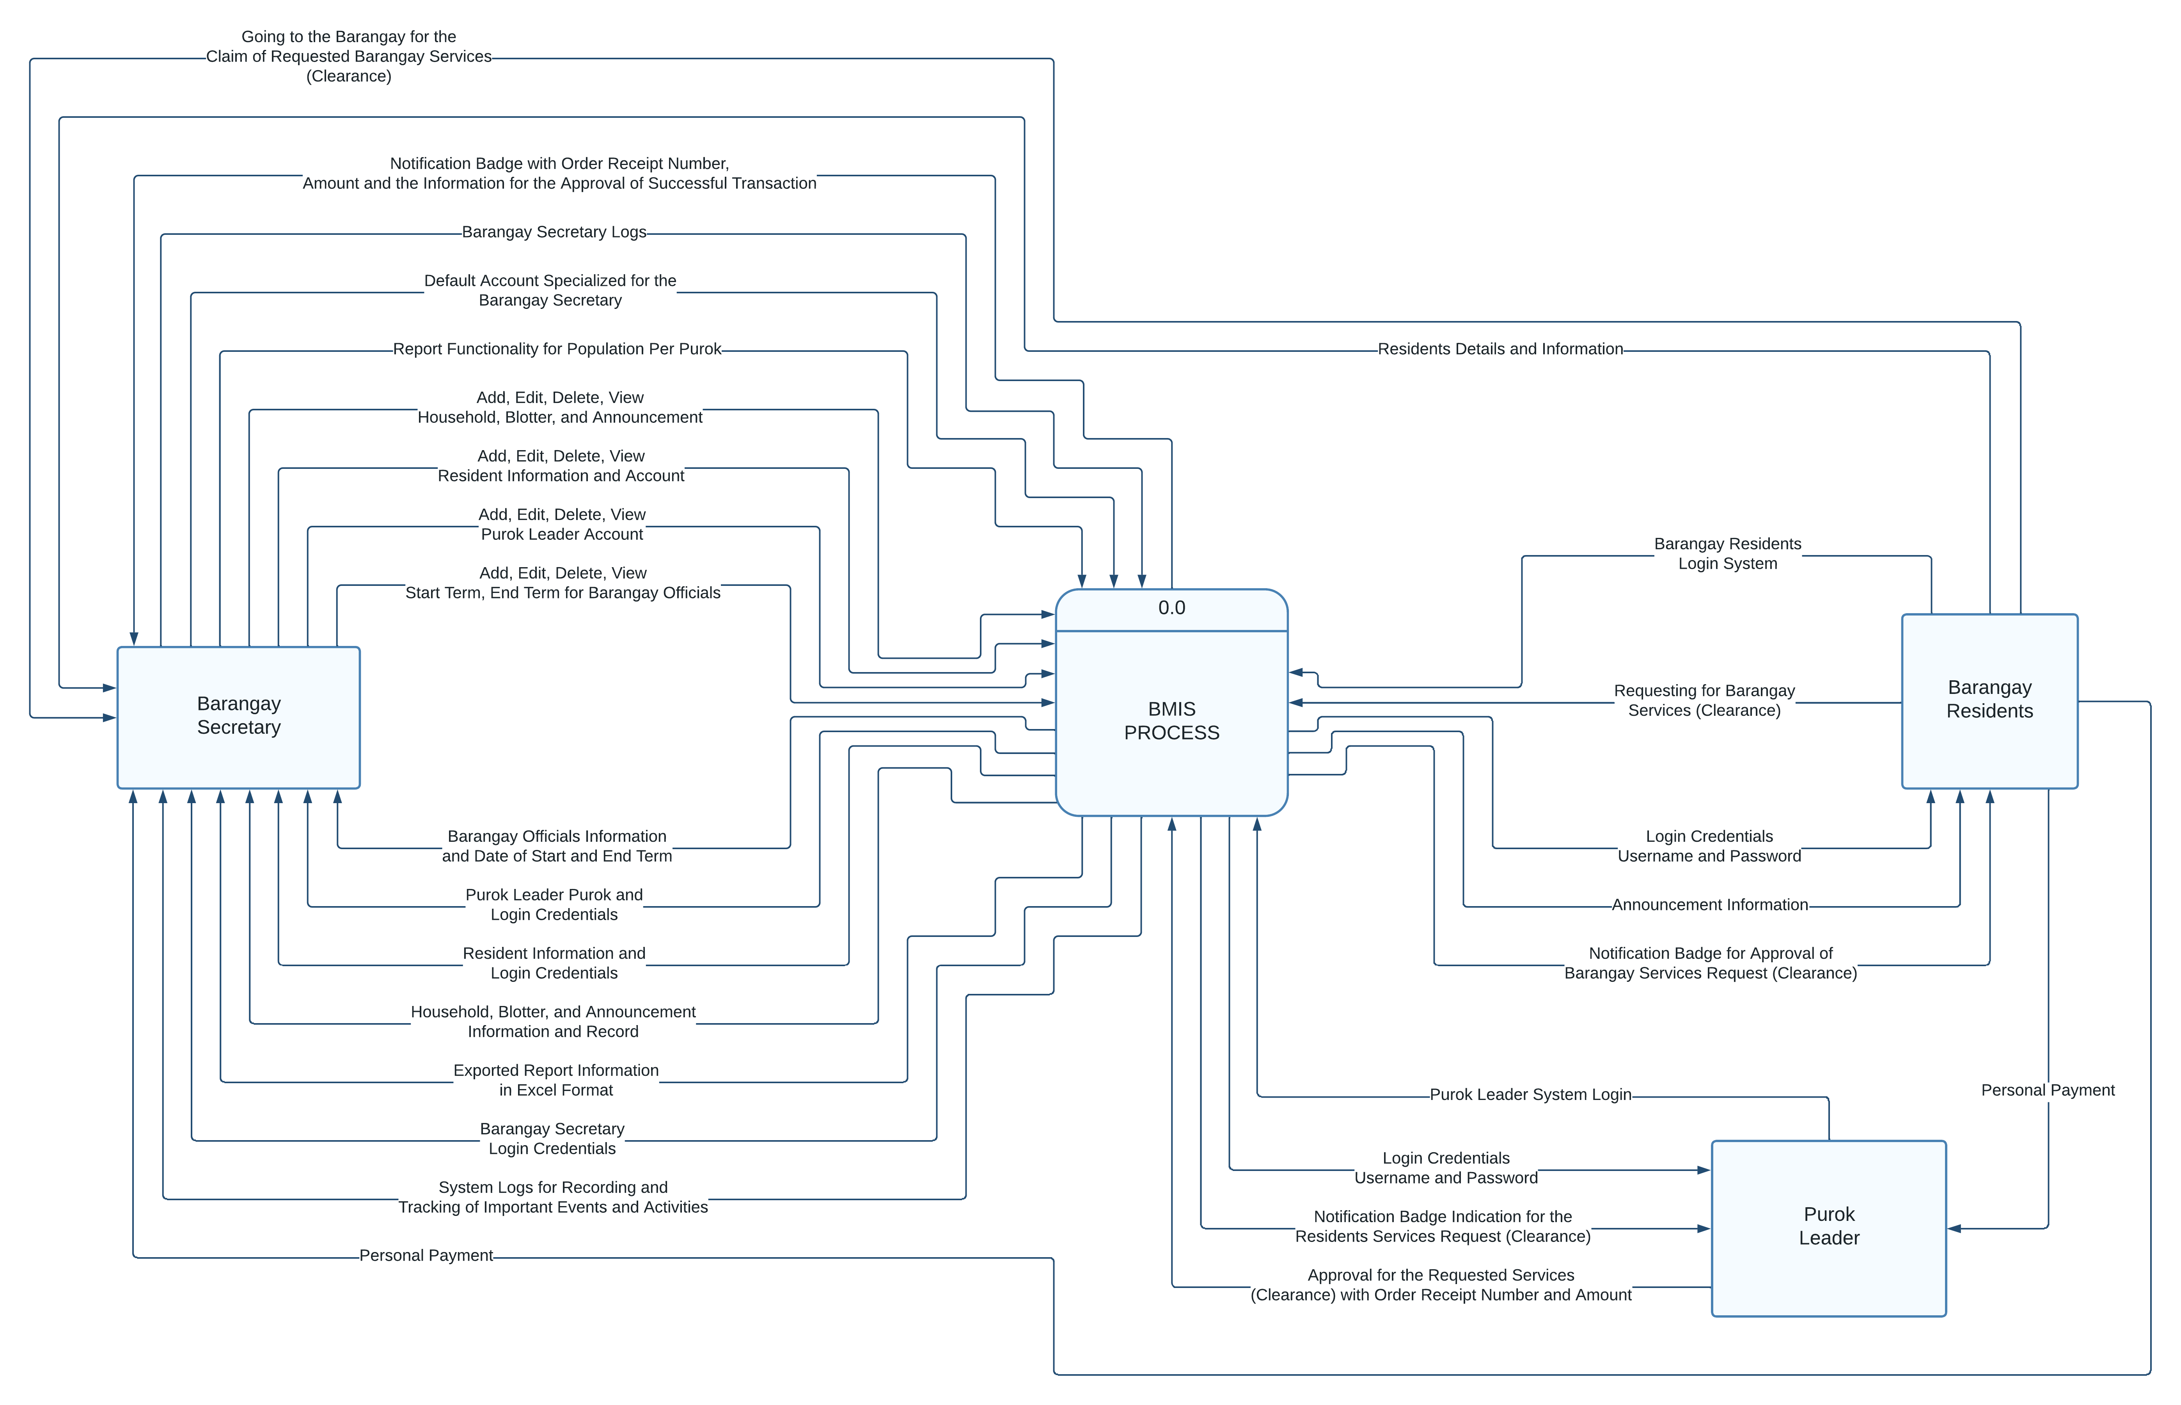

Figure 2.2: Dfd Level 0

## Definition of Terms

|  |  |
| --- | --- |
| **Term** | **Definition** |
| **Management Information System (MIS)** | A Management Information System (MIS) is a computer-based system that collects, stores, analyzes, and presents data and information to support decision-making, planning, and control processes within an organization or in this case, a barangay. It provides a framework for managing and organizing data, facilitating efficient administrative processes, improving transparency, and enabling effective communication and collaboration among stakeholders. |
| **Barangay** | A barangay is the smallest administrative division in the Philippines, often referred to as a village or neighborhood. It serves as the primary unit of local government, responsible for delivering basic public services and promoting the welfare of its residents. A barangay is headed by a barangay captain and consists of elected officials and community members who work together to address the needs and concerns of the local community. |
| **New Pandan, Panabo City** | New Pandan is a specific barangay located in Panabo City, Davao del Norte, Philippines. It is a distinct area within the city boundaries, comprising a community of residents, businesses, and institutions. The capstone project focuses on implementing a Management Information System (MIS) specifically designed for Barangay New Pandan, aiming to enhance its governance, service delivery, and community engagement. |
| **User Interface (UI)** | User Interface (UI) refers to the visual and interactive elements of a software application or system that allow users to interact with and control the system. It encompasses the design, layout, and presentation of information, menus, buttons, forms, and other visual components that facilitate user interaction. In the capstone project, the user interface of the Management Information System (MIS) will be developed with a user-friendly and intuitive design to enhance user experience and enable easy navigation and access to the system's functionalities. |
| **Database** | A database is a structured collection of organized data stored and managed on a computer system. It serves as a central repository for storing and retrieving information, providing a structured way to store, organize, and manage data efficiently. In the capstone project, a database will be utilized within the Management Information System (MIS) to store and manage various types of data, including resident information, service records, financial transactions, and other relevant data required for effective barangay management. |
| **Service Delivery** | Service delivery refers to the process of providing and delivering services to meet the needs and expectations of individuals or communities. In the context of the capstone project, service delivery focuses on the delivery of essential services by the barangay to its residents, such as healthcare, public safety, infrastructure maintenance, and community programs. The Management Information System (MIS) will aim to streamline and improve service delivery processes, ensuring efficient allocation of resources, effective monitoring, and timely provision of services to the community members of Barangay New Pandan. |
| **Administrative Processes** | Administrative processes refer to the various activities, procedures, and tasks involved in managing and carrying out the day-to-day operations and functions of an organization or institution. In the context of the capstone project, administrative processes encompass the tasks related to barangay governance, such as record-keeping, document management, resident registration, permit processing, and other administrative duties. The Management Information System (MIS) aims to automate and streamline these administrative processes, reducing manual workloads, improving efficiency, and enabling accurate and timely information management for effective decision-making. |
| **Stakeholders** | Stakeholders are individuals, groups, or organizations that have a vested interest or are directly affected by a particular project, initiative, or organization. In the capstone project, stakeholders include barangay officials, staff, residents, community organizations, and government agencies involved in barangay management and service delivery. Engaging stakeholders is crucial for the successful implementation of the Management Information System (MIS) as their input, collaboration, and support are essential for system adoption, effective utilization, and sustainability. The MIS will provide mechanisms for stakeholder engagement, ensuring their active participation, feedback, and involvement in the decision-making processes of the barangay. |
| **User Roles and Permissions** | User roles and permissions define the specific access rights, privileges, and responsibilities assigned to different users within a system. In the capstone project, user roles and permissions will be established in the Management Information System (MIS) to ensure appropriate data access and control. Different user types, such as barangay officials, staff, and residents, may have varying levels of access to specific features or information within the system. User roles and permissions help maintain data security, confidentiality, and integrity by controlling the actions and data visibility of each user within the MIS. |
| **User Feedback** | User feedback refers to the opinions, suggestions, and evaluations provided by users of a system or software regarding their experiences, usability, and satisfaction. In the capstone project, user feedback will be actively sought and collected from barangay officials, staff, and residents who interact with the Management Information System (MIS). Feedback can be gathered through surveys, interviews, or feedback forms, allowing users to express their thoughts, identify issues, and propose improvements. User feedback plays a vital role in identifying areas for enhancement, addressing user needs, and continuously improving the usability and effectiveness of the MIS. |

# OPERATIONAL FRAMEWORK

## Materials

1. Hardware
2. Software
3. Database
4. Server
5. Laptop
6. Monitor
7. Mouse & Keyboard

### Software

|  |  |
| --- | --- |
| **Software** | **Specification** |
| SQL | Any Version |
| PHP | Any Version |
| Operating System | Windows 10x64, … |
| Database | MySQL |
| Web Browser | Chrome, Firefox |

Table 3.1 List of the Software Requirements

### Hardware

|  |  |
| --- | --- |
| **Hardware** | **Specification** |
| Motherboard | USB |
| Keyboard | USB |
| Mouse | USB |
| Printer | EPSON |
| Hard disk | 80 GB and above |
| RAM | 2GB higher |
| Processor | Intel, Amd |
| Computer Monitor | Desktop, Laptop |

Table 3.2 List of Hardware Requirements

### Data

|  |  |  |  |
| --- | --- | --- | --- |
| **KEY** | **COLUMN** | **TYPE** | **NULL** |
| PRIMARY | RESIDENTID | int(9) | NO |
|  | FNAME | varchar(255) | NO |
|  | LNAME | varchar(255) | NO |
|  | NAME | varchar(255) | NO |
|  | ADDRESS | varchar(255) | NO |
|  | SEX | varchar(255) | NO |
|  | CIVILSTATUS | varchar(255) | NO |
|  | BIRTHDATE | varchar(255) | NO |
|  | BIRTHPLACE | varchar(255) | NO |
|  | AGE | varchar(255) | NO |
|  | CONTACTNO | varchar(255) | NO |
|  | PRECINT NO | varchar(255) | NO |

Table 3.1.3. Resident Data

|  |  |  |  |
| --- | --- | --- | --- |
| **KEY** | **COLUMN** | **TYPE** | **NULL** |
| PRIMARY | BARANGAY OFFICIAL ID | int(11) | NO |
|  | FNAME | varchar(10) | NO |
|  | LNAME | varchar(10) | NO |
|  | CONTACT NO | varchar(11) | NO |
|  | POSITION | varchar(30) | NO |
|  | AGE | varchar(2) | NO |
|  | BIRTHDAY | varchar(20) | NO |

Table 3.1.4. Barangay Official Data

## Methods

We have adopted the Agile methodology, specifically utilizing the Scrum framework, for the development of our capstone project titled "Barangay Management Information System in Barangay New Pandan, Panabo City." Agile Project Management with Scrum by Ken Schwaber serves as a valuable reference for our team, providing insights and guidance on implementing Agile practices and leveraging Scrum for effective project management and software development (Schwaber, 2004). By incorporating the principles and practices outlined in Schwaber's book, we aim to maximize collaboration, flexibility, and productivity throughout our project's lifecycle.

Figure 3.1. Agile Model

### Experimental design

For this capstone project, titled "Management Information System in Barangay New Pandan, Panabo City," we have chosen an experimental design using a pretest-posttest design with a control group. Following the principles outlined in Ken Schwaber's book, "Agile Project Management with Scrum" (Schwaber, 2004), we will implement the Agile methodology to guide the development and evaluation of the Management Information System (MIS). Participants, including barangay officials, staff members, and residents, will be randomly assigned to either the experimental group (exposed to the MIS) or the control group (not exposed to the MIS). We will collect data through surveys, interviews, and document analysis before and after the MIS implementation to assess the efficiency and effectiveness of administrative processes, service delivery, and transparency in barangay governance. The collected data will be analyzed using descriptive statistics, qualitative thematic analysis, and document analysis. Ethical considerations, such as informed consent and data privacy, will be upheld throughout the study. By adopting an experimental design within an Agile framework, we aim to evaluate the impact and effectiveness of the MIS implementation in Barangay New Pandan, Panabo City.

Reference:

Schwaber, K. (2004). Agile Project Management with Scrum. Microsoft Press.

### Procedures for the different phases

Phase 1: Project Initiation

1. Define project objectives: Clearly articulate the goals and objectives of the capstone project, including the development of the Management Information System (MIS) for Barangay New Pandan, Panabo City.
2. Conduct a needs assessment: Identify the specific requirements and challenges of the barangay administration and residents that the MIS should address. Gather input from stakeholders through surveys, interviews, and observations.
3. Develop a project plan: Create a detailed project plan outlining the tasks, milestones, timeline, and resource allocation for each phase of the project.

Phase 2: System Analysis and Design

1. Gather system requirements: Conduct interviews and workshops with barangay officials, staff members, and residents to gather detailed requirements for the MIS. Document the functional and non-functional requirements.
2. Design system architecture: Create a system architecture that outlines the overall structure and components of the MIS. Define the database structure, user interface design, and integration requirements.
3. Prototype development: Develop a preliminary version of the MIS to demonstrate key functionalities and obtain feedback from stakeholders. Use rapid prototyping techniques to iterate and refine the design.

Phase 3: System Development and Testing

1. Implement the MIS: Based on the system design and prototype, develop the full-fledged MIS using appropriate programming languages, frameworks, and technologies.
2. Conduct unit testing: Test individual modules and components of the MIS to ensure they function as intended. Identify and fix any bugs or errors.
3. Perform system integration and testing: Integrate all system components and conduct thorough testing to ensure the MIS operates seamlessly. Test functionality, performance, security, and user experience.

### Evaluation

The "Management Information System in Barangay New Pandan, Panabo City" capstone project holds significant potential for improving the overall efficiency, transparency, and service delivery in the barangay. By implementing an MIS tailored to the specific needs and requirements of Barangay New Pandan, the project aims to address the challenges faced by the barangay administration and enhance their information management processes.

The evaluation of the capstone project will encompass various aspects, including the effectiveness of the developed MIS in streamlining administrative tasks, improving data accuracy and accessibility, and facilitating communication among barangay officials, residents, and other stakeholders. The project's success will be measured by its ability to provide a user-friendly interface that simplifies the process of resident profiling, barangay officials' management, document management, and reporting functionalities.

The evaluation will also consider the impact of the MIS on service delivery within the barangay. The project aims to expedite the issuance of certificates and permits, track barangay projects effectively, and monitor community development initiatives. Therefore, the evaluation will assess the efficiency and timeliness of these processes after the implementation of the MIS.

User satisfaction and feedback will play a crucial role in evaluating the capstone project's success. The usability, functionality, and performance of the MIS will be assessed through user testing and feedback from barangay officials, staff, and residents. User satisfaction surveys and qualitative interviews will provide insights into the system's effectiveness in meeting the users' needs and expectations.

Furthermore, the evaluation will focus on the long-term sustainability of the MIS. The training provided to barangay officials and staff on the utilization and maintenance of the system will be evaluated to ensure their proficiency and confidence in using the system independently. Additionally, an assessment of the MIS's scalability and adaptability to future needs and technological advancements will be conducted to ensure its longevity.

The evaluation will also examine the impact of the implemented MIS on the overall transparency and accountability of barangay operations. It will assess whether the system enables easy access to information and documents, promotes transparency in decision-making processes, and enhances public trust and satisfaction.

In conclusion, the evaluation of the capstone project will assess the effectiveness, efficiency, user satisfaction, sustainability, and impact of the "Management Information System in Barangay New Pandan, Panabo City." The evaluation process will provide valuable insights into the project's success and areas for improvement, ensuring that the MIS contributes significantly to the enhancement of barangay governance and service delivery.

## Amenities Images

Figure 1: Homepage or Welcome Page

Figure 2: Secretary Login Page

Figure 3: Dashboard

Figure 4: Barangay Officials

Figure 5: Barangay Officials (Add Official)

Figure 6: Purok Leader

Figure 7: Purok Leader (Add Purok Leader)

Figure 8: Resident Profiling

Figure 9: Resident Profiling (Add Resident Profiling)

Figure 10: Household

Figure 11: Household (Add Household)

Figure 12: Blotter

Figure 13: Blotter (Add Blotter)

Figure 14: Clearance

Figure 15: Clearance (Add Clearance)

Figure 16: Announcement

Figure 17: Announcement (Add Announcement)

Figure 18: Reports

Figure 19: Logs

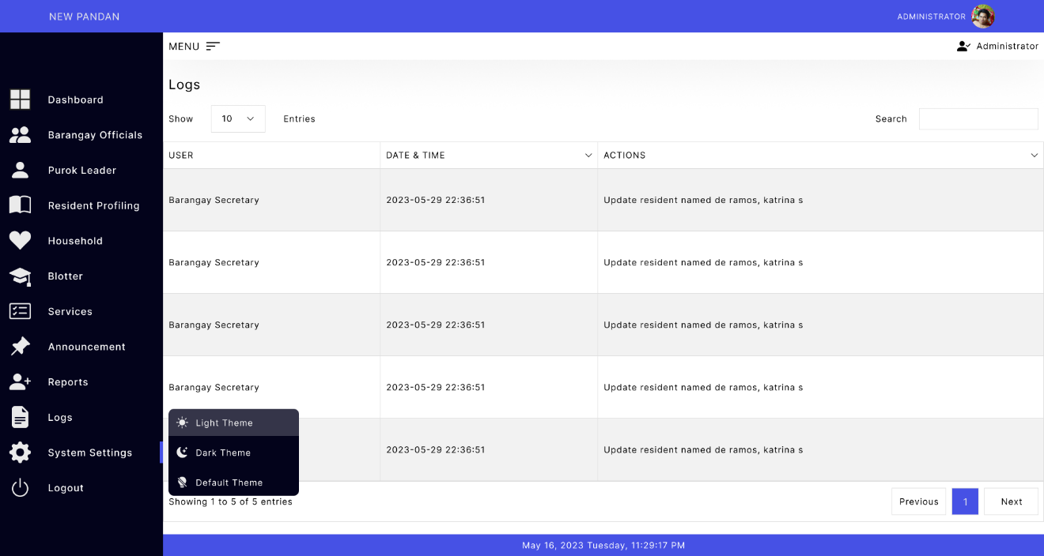

Figure 20: System Settings (Light Theme)

Figure 21: System Settings (Dark Theme)

Figure 22: Logout

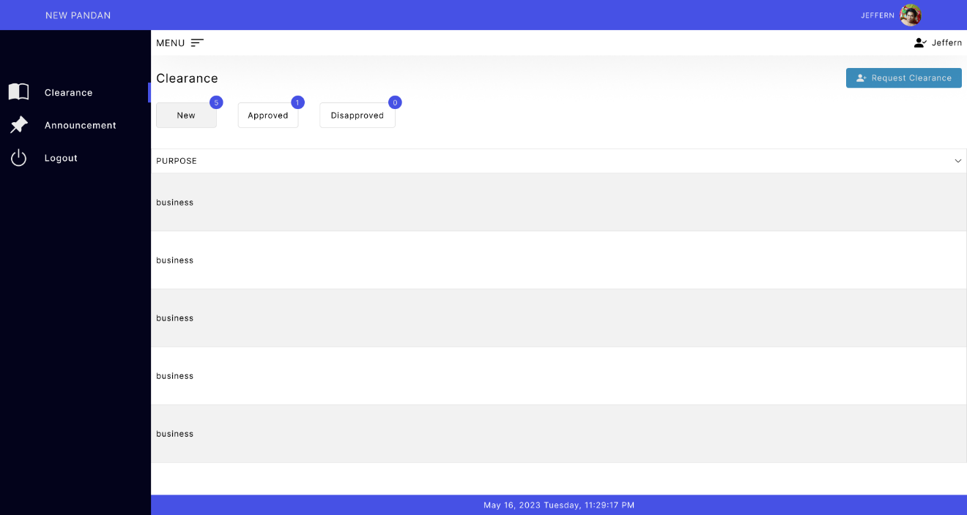

Figure 23: Resident Account (New Clearance Request)

Figure 24: Resident Account (Approved Clearance Request)

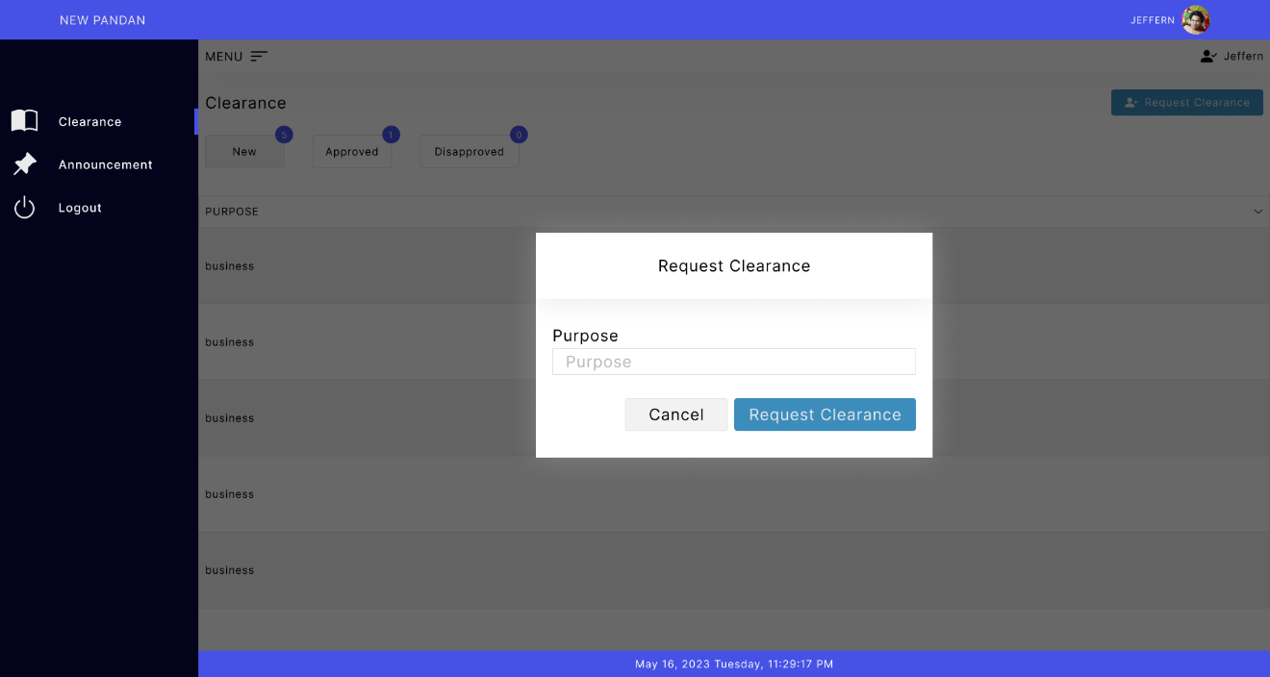

Figure 25: Resident Account (Request Clearance)

Figure 26: Resident Account (Announcement)

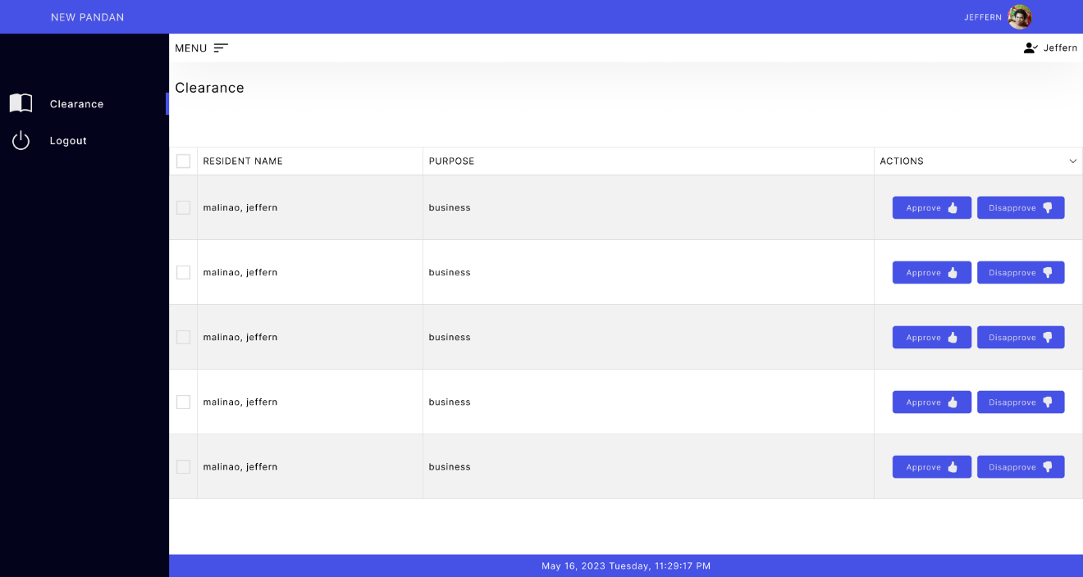

Figure 27: Purok Leader (Clearance Request List)

Figure 28: Purok Leader (Clearance Request Approval)